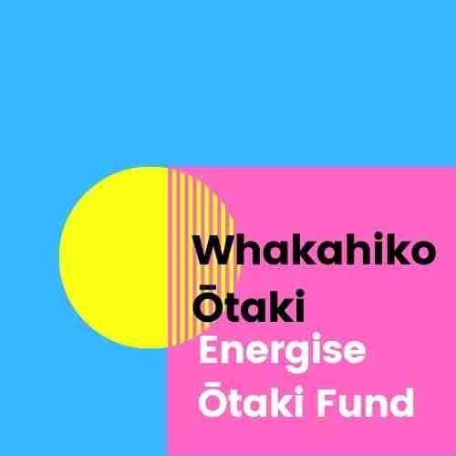

Grant application form
Applications close 21st October, 2022

Applicant Name: Type here
Organisation (if applicable): Type here
Address: Type here
Email: Type here
Telephone number: Type here
Your Project Proposal
- Tell us about your project idea!
Type here
- Which Fund principle or principles does your project relate to, and how?
(The principles are here: energise.otaki.net.nz/content/whakahiko-principles )
Type here
Who benefits?
- Who will directly benefit from your project?
Type here
- How might the Ōtaki community benefit overall?
Type here
- How long will your project run for?
Type here
Funding
6) What amount are you applying for?
Type here
7) Is your project dependent on other funding as well?
Type here
8) Have you applied for funding elsewhere? If so, where, and were you successful?
Type here
9) What contribution are you making to the project?
Type here
10) How will the funds be used?
Type here
Community Connections
11) Will you be working with others, or other groups? If yes, who?
Type here
12) Are there other Ōtaki groups you might work with? If so, who?
Type here
13) How did you hear about the Whakahiko Ōtaki–Energise Ōtaki Fund? :
Newspaper YES/NO Facebook YES/NO School or other newsletter YES/NO
Poster YES/NO Word of mouth YES/NO Radio YES/NO
Energise Ōtaki’s newsletter YES/NO Energise Ōtaki’s office window YES/NO
Other. Type here
Would you like to present your application as well? There is no obligation to do this. YES/NO
If yes, we will contact you to arrange a time.
Verbal applications will be on Tuesday evening, 25th October.
Please rename this file to include your name, then email it to
whakahiko.otaki@gmail.com
or print it and drop it in at the Energise Ōtaki office, which is at 7 Main St., Ōtaki.
We are open Tuesdays – Thursdays, 10am-2pm.
Award winners will need to provide an account name and account number for payment of their award. Individuals and organisations that are GST registered will need to provide an invoice for payment of an award.
Ngā mihi.

