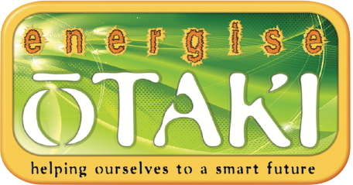
Whakahiko Ōtaki
Energise Ōtaki Fund

Application For Grants 2021
Applications close 1st October, 2021

Applicant Name:
Organisation (if applicable):
Address:
Email:
Telephone number:

Your Project Proposal
- Tell us about your project idea.

- Which fund principle or principles does your project contribute to or fit with, and how?
You can find the principles online at: energise.otaki.net.nz/whakahiko-principles

Who benefits?
- Who will directly benefit from your project?

- How might the Ōtaki community benefit overall?

- How long will your project run for?

Funding
- What amount are you applying for?

- Is your project dependent on other funding as well?

- Have you also applied for funding elsewhere? If so, to which, and were you successful?

- What contribution are you making to the project?

- How will the funds be used?

Community Connections
- Will you be working with others or other groups? If so, who?

- Are there other Ōtaki groups you might work with?

THANK YOU FOR SHARING YOUR ENERGISING IDEA.
The deadline for receiving applications is 1st October, 2021.

Please rename this file to include your name,
and email it to whakahiko.otaki@gmail.com
or print it and drop it in
to the Energise Ōtaki office, which is at 7 Main St and
open Tuesdays – Thursdays from 10am to 2pm
.

